Is Cryptocurrency
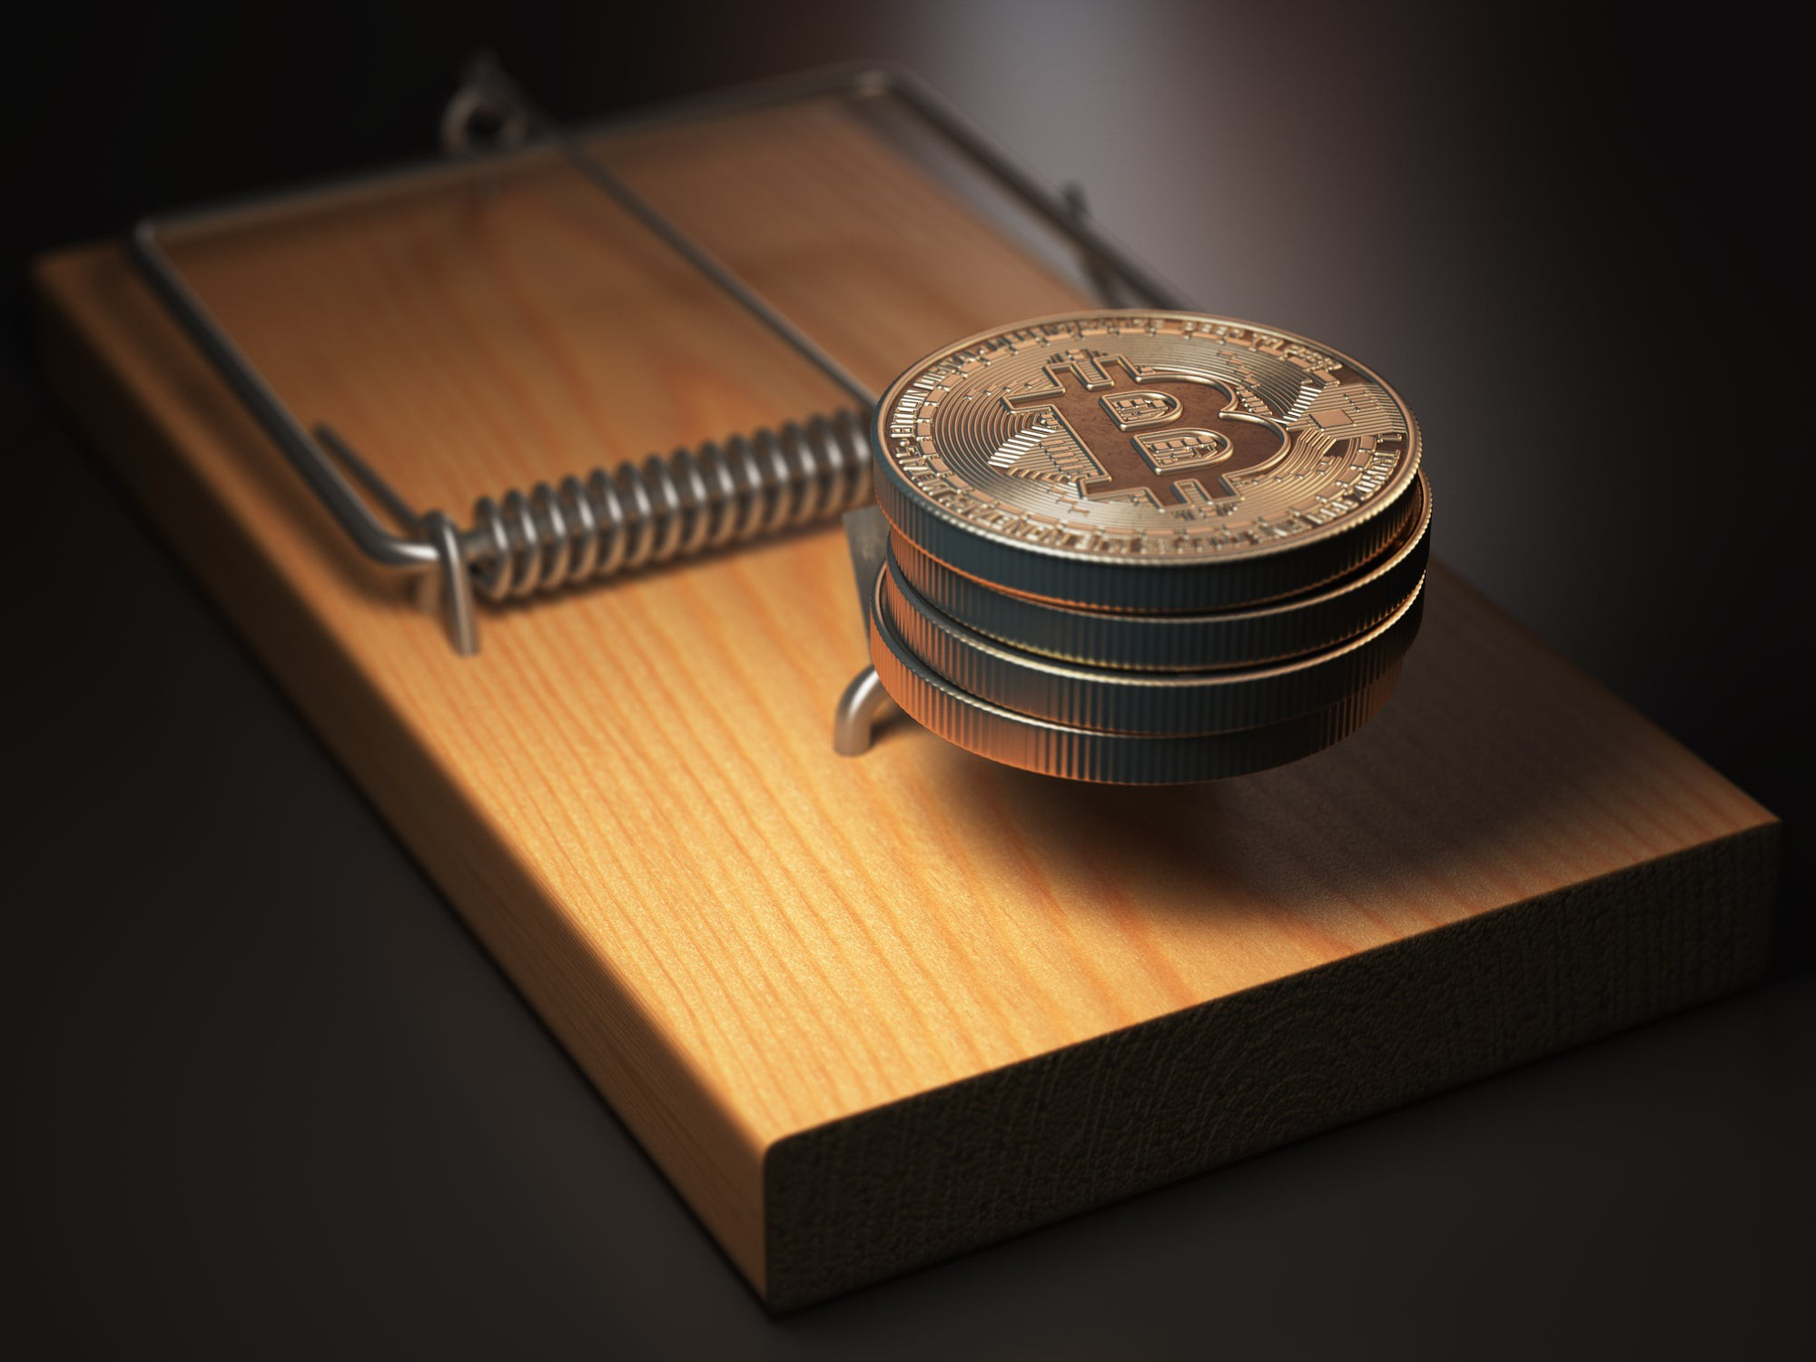

a Good Investment?

Weighing up the pros and cons

of investing in crypto.

Adam Levy

1. It's possible to get filthy rich by investing in cryptocurrency. But you could also lose all your money. How can both of those things be true? Well, like most investments, crypto assets come with a host of risks but also vast potential rewards.

Is cryptocurrency safe?
2. There are certain risks present in the crypto market that are not as prevalent in traditional financial markets, such as those for stocks and bonds. Cryptocurrency exchanges have been prone to hacks and other criminal activity. These security breaches have led to sizable losses for investors who have had their digital currencies stolen, never to be seen again.
3. Frauds and scams are also rampant in the crypto industry. Hypesters who promise investors dazzling returns are typically unable to fulfill their lofty promises since they far too often peddle fool's gold rather than legitimate blockchain projects. Investors who buy into the hype can suffer brutal losses when these projects eventually fail.
4. Moreover, it's not as easy to store cryptocurrencies as it is to store stocks or bonds. While exchanges like Coinbase make it fairly easy to buy and sell crypto assets, such as Bitcoin and Ethereum, many people don't like to keep their digital assets on exchanges due to the aforementioned risk of cyberattacks and theft. Instead, some prefer offline "cold storage" options, such as hardware or paper wallets. But cold storage comes with its own set of challenges, namely the risk of losing your private keys, which would make it impossible to access your cryptocurrency.
5. There's also the risk that the crypto project you invest in will not succeed. There are thousands of blockchain projects, and competition is fierce. Regulators could also crack down on the entire crypto industry if more governments begin to view cryptocurrencies as a threat rather than just an innovative technology.
6. Lastly, it's important to understand that cryptocurrencies and blockchain in general are cutting-edge technologies. While that makes them exciting, it also increases the risks for investors since much of this tech is still being developed and is not yet proven in real-world scenarios. Buying cryptocurrency is very much early-stage investing, and investors should expect venture capital-like outcomes in which the vast majority of crypto projects fail and become worthless. Only a small number of projects will ultimately succeed, and it's unclear if these big wins will be enough to offset the many losses.
7. That said, the blockchain industry is growing stronger every day. Much-needed financial infrastructure is being built -- such as institutional-grade custody services and futures markets -- and that's giving professional and individual investors the tools they need to manage and safeguard their crypto assets. Financial giants such as PayPal and Square are making it easier to buy and sell cryptocurrency on their popular platforms.
8. Major corporations, such as MicroStrategy and Square, have collectively invested hundreds of millions of dollars in bitcoin and other digital assets. Tesla bought $1.5 billion worth of bitcoin in early 2021 and made plans to accept the currency as payment for its cars. These companies clearly see the potential of cryptocurrency - as do a growing number of individual investors - and they believe the industry has matured to a point where investing sizable sums in crypto assets is safe.

Is crypto a good long-term investment?
9. Whether crypto assets pay off for investors will ultimately be determined by whether they achieve wide-scale adoption.
10. Bitcoin, for example, is seen by many as an investment akin to gold. Unlike fiat currencies, such as the U.S. dollar and Japanese yen, which can seemingly be printed at the will of politicians, bitcoin has a maximum supply of just under 21 million coins. Many investors thus view bitcoin as a scarce asset that could increase in value as fiat currencies depreciate. Others believe bitcoin could eventually gain extensive use as a digital form of cash, with some going so far as to say it has the potential to become the first truly global currency.
11. Ethereum, meanwhile, wants to serve as a global computing platform. It serves as a launchpad for decentralized applications, or "dapps," which are open source and not controlled by a single organization. Ethereum allows the use of smart contracts, which have their terms written directly into code and can be executed automatically. These technologies could disrupt massive industries, such as real estate and banking, and potentially create entirely new markets.
12. If Bitcoin and Ethereum can achieve these aims, then investors who buy their tokens today will likely be richly rewarded in the years ahead. But there are many other projects competing with these cryptocurrency leaders, and their success is not assured by any means.

Are there better investments than cryptocurrency?
13. There are other ways to potentially profit from blockchain technology besides investing directly in cryptocurrencies.
14. One solid option is to buy the stocks of companies that are rapidly adopting this game-changing tech. As we've mentioned, Square and PayPal are offering cryptocurrency services to their users, and both of these digital payment leaders are well-positioned to benefit from the rising usage of bitcoin and other digital assets. Investing in CME Group, which operates one of the largest bitcoin futures exchanges, is another great way to profit from the growth of digital asset trading.
15. Of course, which of these options is best for you is something you'll need to decide for yourself. Hopefully, this article has given you some key factors to consider that will help you make the correct choice for your personal investment portfolio.


