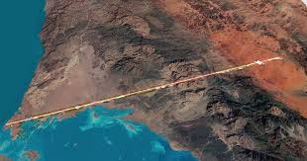
15th January, 2021

Saudi Arabia plans 170km city without roads in Neom economic zone

Muhammad Bin Salman, the crown prince of Saudi Arabia, has announced plans to build a car-less, zero-carbon city with 1 million inhabitants and no roads, laid out as a 170km-long belt with services and transport infrastructure built underground.
Called “The Line”, the idea is part of Neom, the futuristic economic zone earmarked for the country’s northwest, on the coasts of the Red Sea and Gulf of Aqaba. According to the Saudi Press Agency, the city will be “built around nature” as “a response to some of the most pressing challenges facing humanity today, such as legacy infrastructure, pollution, traffic and human congestion”.
The absence of roads, and vehicles, will not inconvenience the city’s inhabitants since “all essential daily services, such as schools, medical clinics, leisure facilities as well as green spaces will be located within a five-minute walk”. A graphic produced by Neom, the company that Salman chairs, shows trains and autonomous freight vehicles running in “an invisible layer of infrastructure” beneath the city.
For longer distance travel, inhabitants will have access to “ultra-high-speed transit and autonomous mobility solutions” with “no journey longer than 20 minutes”.
The city, which is being badged as part of the kingdom’s Vision 2030 strategic plan, will be run by artificial intelligence, enhanced by machine learning and 5G systems, that “predict ways to make life easier” – for example, by subcontracting service and maintenance work to robot maids and gardeners.
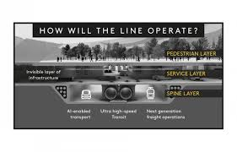
Energy will come entirely from renewable sources and its physical infrastructure will be built “around nature, instead of over it”, which means in practice that 95% of what was there before the city is built will still be there after work is completed.
Construction of The Line will begin in the first quarter of this year, and will initially be funded by Saudi Arabia’s Public Investment Fund. The aim is for later stages to be built as international projects, “led and funded by people from all over the world” with the aim of creating 380,000 jobs and adding $48bn a year the kingdom’s GDP by 2030.
Top image: Neom’s rendering of the Line

